Quick Start Guide for QAF (Qmetry Automation Framework)

Table of Contents
Perquisites: 2
Setting up the framework: 2
Creating Tests: 2
Running Tests: 4
Verifying Results: 6
Parametrizing Scenarios: 7
Common Issues: 8

Perquisites:
- Java is installed and configured.
- Eclipse IDE with Maven plugin is installed.
- User should be aware of Basic Java, Selenium & BDD concepts

Setting up the framework:
- Install Eclipse’s BDD editor plugin from below link.
https://qmetry.github.io/qaf/editor/bdd/eclipse/
- Download template QAF project from below location
https://github.geo.conti.de/uie27734/qaf_template_project
- Import project to Eclipse

Creating Tests:
- Add new pages in “com.web.pages” package and add page objects.
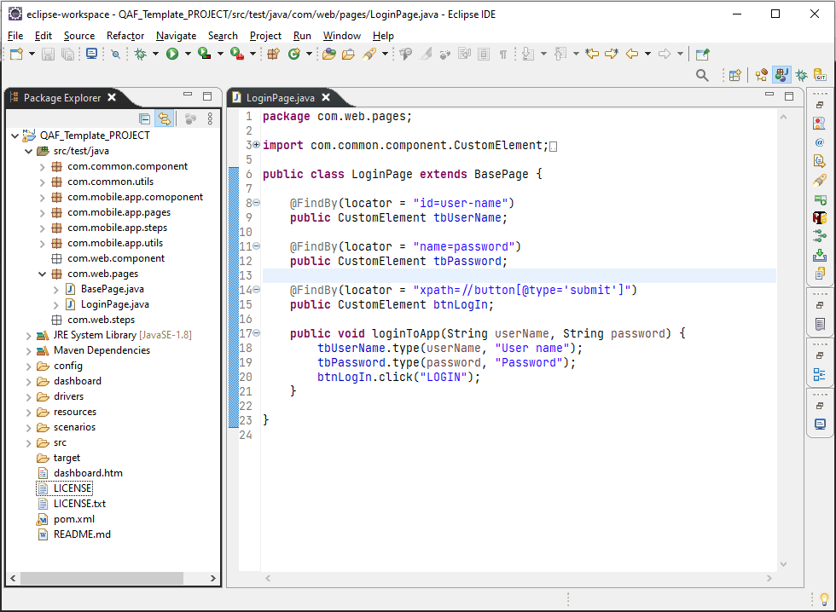

- Create feature file to define scenarios in “scenarios” folder.
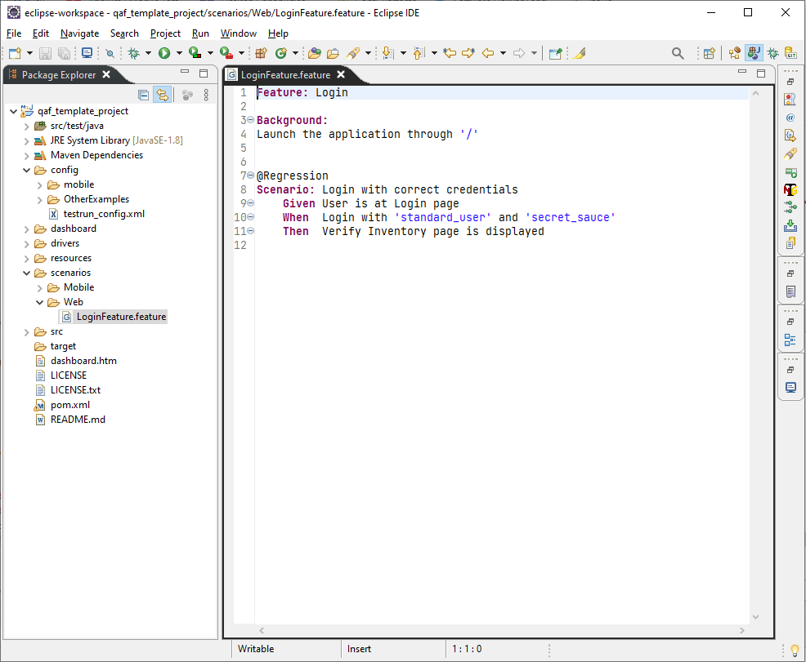

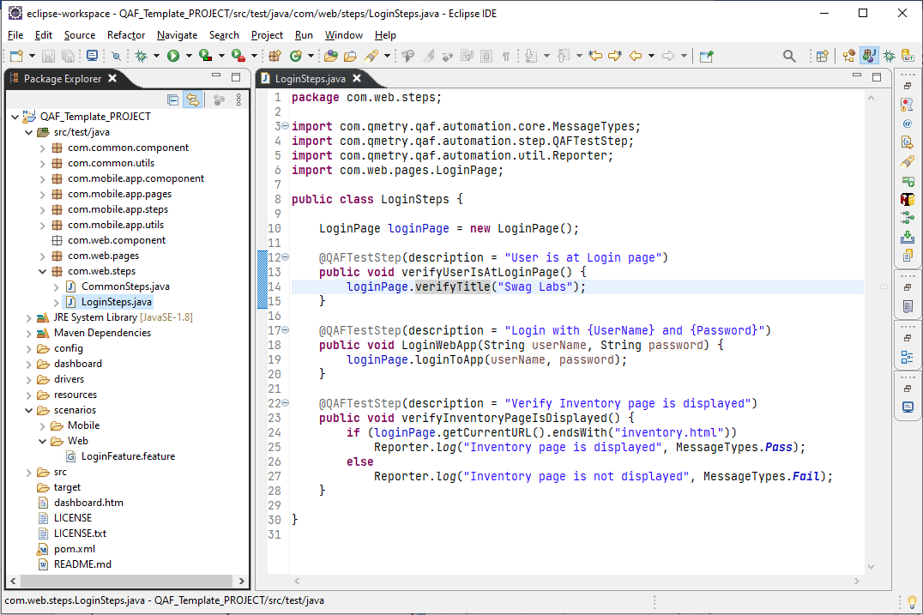
- Create steps definitions for the BDD steps in “com.web.steps” package.

Running Tests:
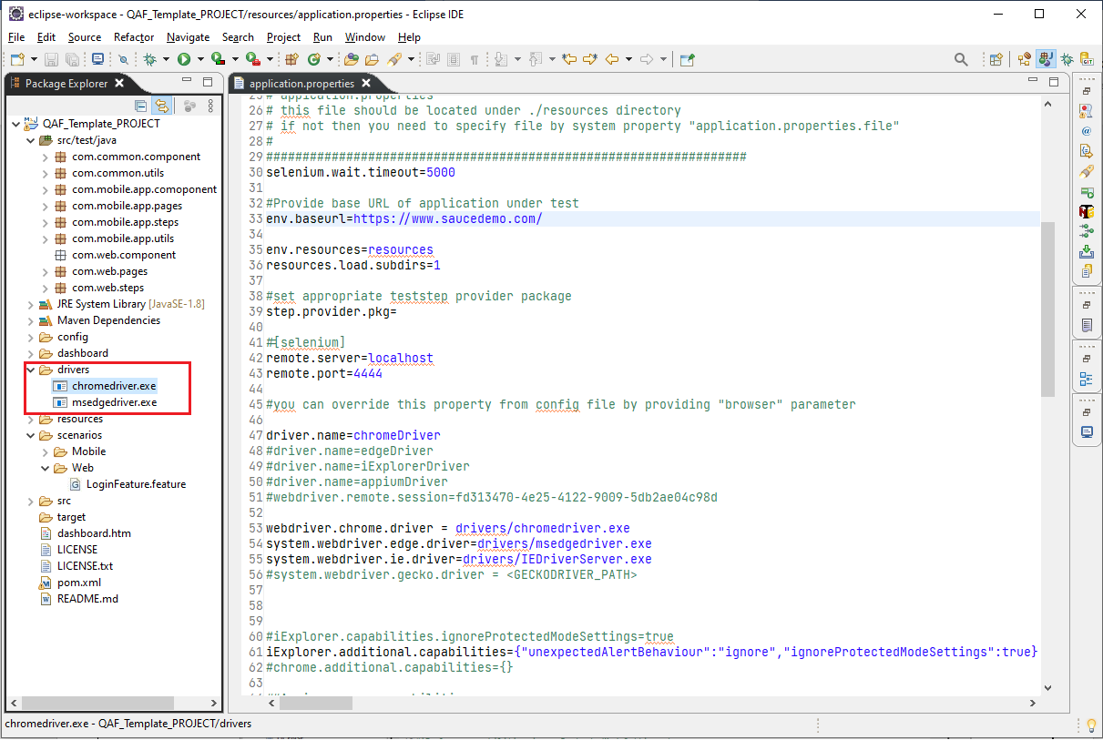
- Download correct driver for the browser that you are going to use and move them to “drivers” folder.

- Setup appropriate properties in “resources/application.properties” file.
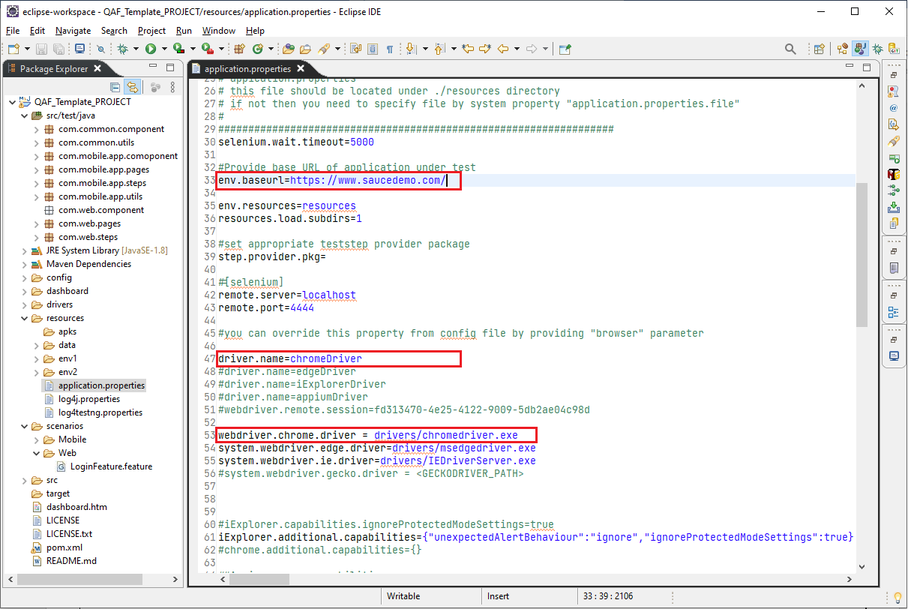
- Create config (testNg runner) file for running scenarios. Add parameters “step.provider.pkg” and “scenario.file.loc” and assign appropriate values to the parameters. Include groups (Tags) that need to be executed.

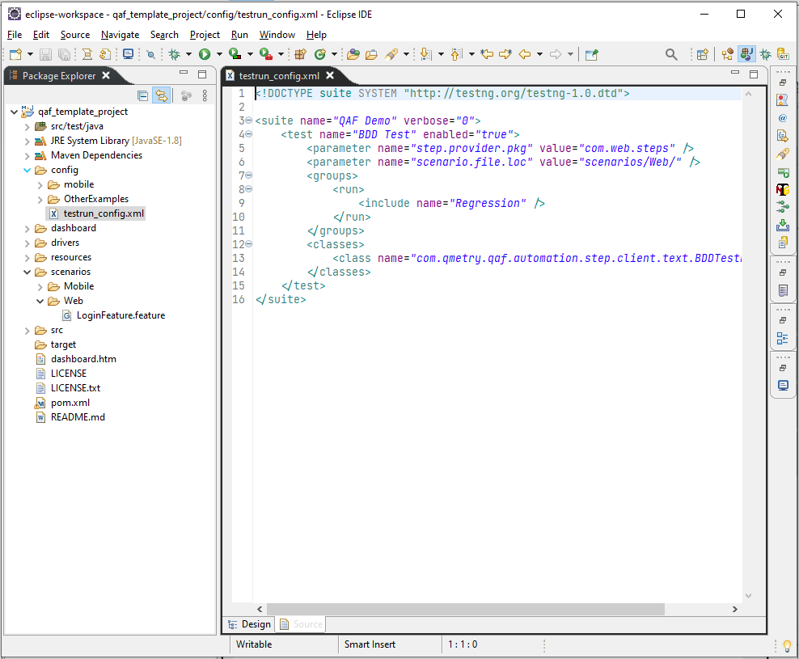

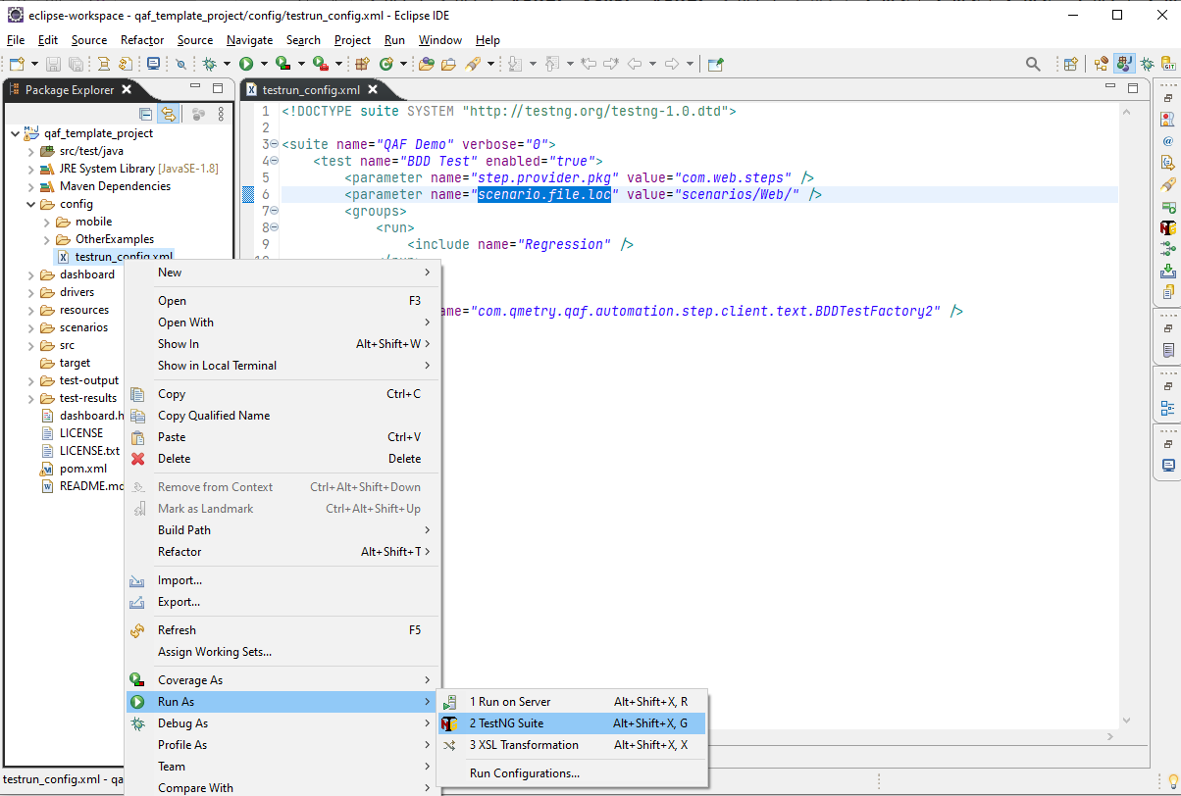
- Right click on config file and run as TestNg suite.

Verifying Results:
- Launch “dashboard.htm” to see the results.

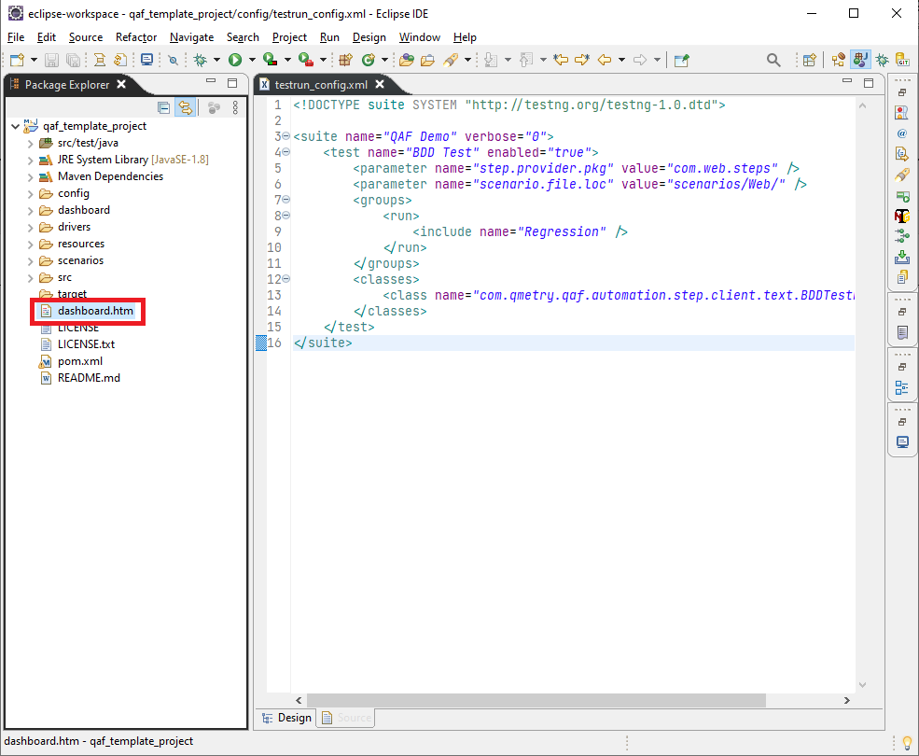
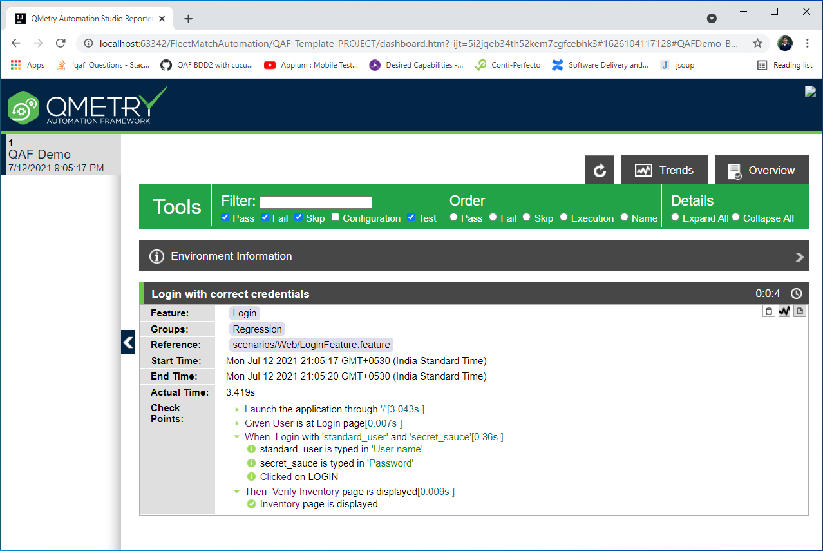

Parametrizing Scenarios:
Note: QAF supports CSV, XML, JSON, Excel, Database. For demo we are using Excel as source. QAF uses unique keys to identify test data for each scenario in excel file.
- Create a “Testdat.xls” file in “resources/data” folder.
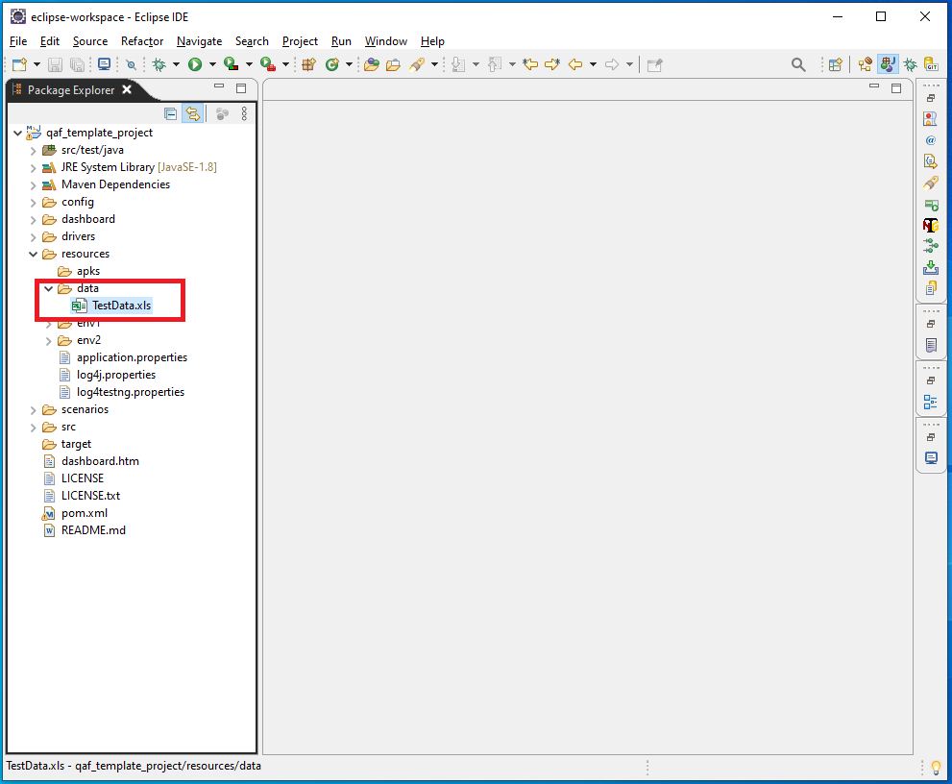
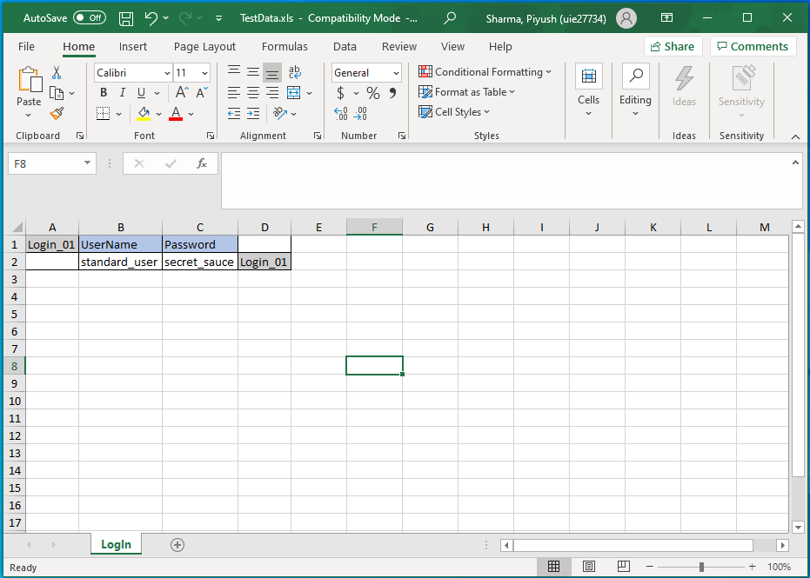
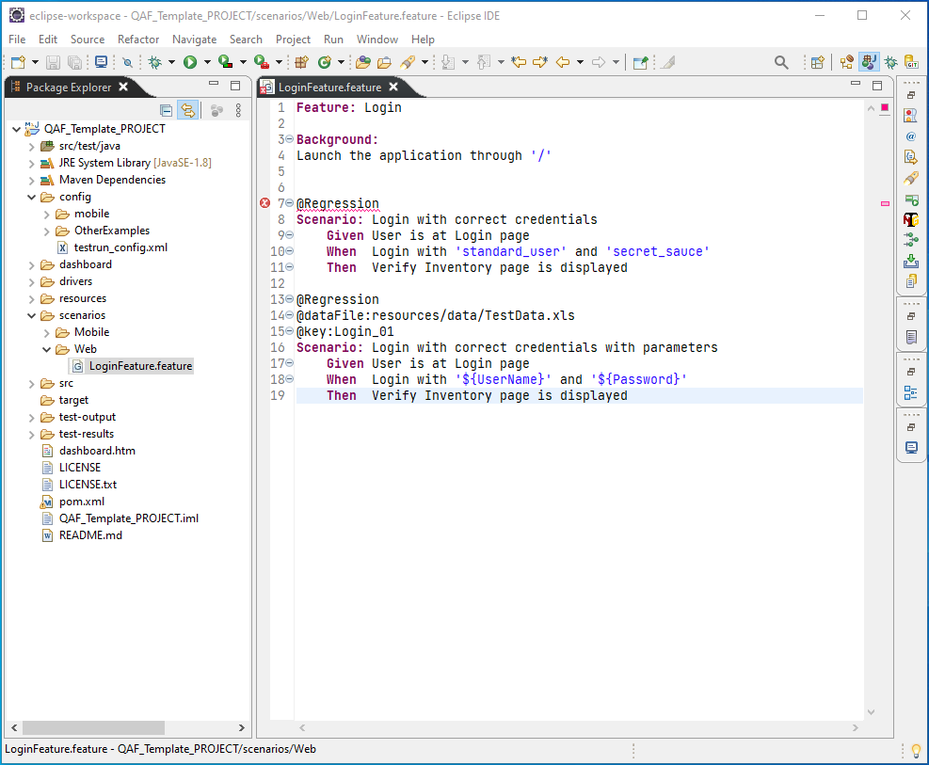
- Add @dataFile, @key tag with appropriate values to scenarios that needs to be parameterized then use ‘${ParamName}’ to assign value to a step at run time.

Common Issues:
Issue: “Plugin execution not covered by lifecycle configuration” error in pom.xml when project is imported to eclipse
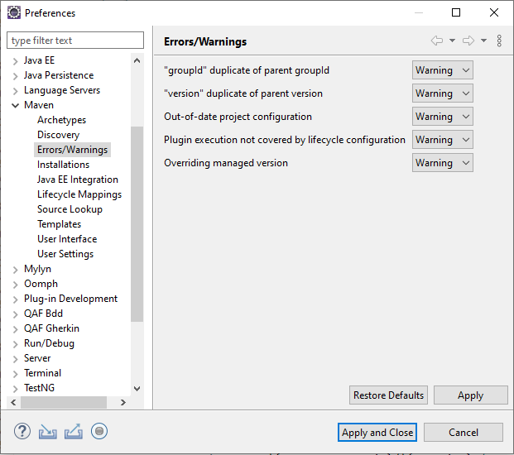
Resolution: Go to eclipse -> windows -> preferences ->maven -> Error/Warning then set all options as per below image and do maven update.

